
FACULTY OF ENGINEERING
DEGREE ENGINEERING
DEPARTMENT OF COMPUTER ENGINEERING
SOFTWARE ENGINEERING (BE103505)
Unit-4 –Requirement Analysis and Specification

Requirement Engineering Process
Requirement Engineering is the process of collecting, understanding, documenting, and managing the customer's requirements for software.

Steps of Requirement Engineering

1. Inception
- Understand the problem and customer needs.
- Identify stakeholders (customers, users, developers).

2. Elicitation
- Gather requirements from stakeholders.
- Use interviews, meetings, questionnaires, etc.

3. Elaboration
- Analyze and organize the requirements.
- Create simple models and user scenarios.

4. Negotiation
- Discuss and agree on the final requirements.
- Find a solution that satisfies both the customer and the development team.

5. Specification
- Write the requirements clearly in a document.
- This document is called the Software Requirement Specification (SRS).

6. Validation
- Check whether the requirements are correct, complete, and clear.
- Remove errors and conflicts.

7. Requirements Management
- Manage and update requirements if they change during the project.
- Track all changes properly.

Requirement Elicitation
- Requirement Elicitation: Collect requirements from customers and users.
- Collaborative Requirement Gathering: Developers and customers discuss requirements together.
- QFD (Quality Function Deployment): Converts customer needs into technical requirements.
- Usage Scenarios (Use Cases): Show how users will use the system.
- Elicitation Work Products: Scope, requirements list, stakeholders, use cases, and prototype.

System Requirement Specification (SRS)
- SRS: A document that describes what the software should do, not how it will do it.

Characteristics of a Good SRS
- Correct: Right requirements.
- Unambiguous: Clear meaning.
- Complete: All requirements included.
- Ranked: Requirements prioritized.
- Modifiable: Easy to update.
- Traceable: Easy to track.
- Verifiable: Can be tested.
- Consistent: No conflicting requirements.

Functional and Non-Functional Requirements

Functional Requirements
- Describe what the system should do.
- Define the features and functions of the software.
Examples (Hotel Management System):
- Book a room.
- Check-in and check-out customers.
- Cancel or modify reservations.
- Record customer details.
- Generate bills.
- Record food orders and payments.

Non-Functional Requirements
- Describe how the system should work.
- Focus on quality, performance, security, and reliability.

Types
- Product Requirements: Speed, reliability, performance.
- Organizational Requirements: Company standards and development rules.
- External Requirements: Legal rules and compatibility with other systems.
Examples (Hotel Management System):
- Login within 5 seconds.
- Screen loads within 2 seconds.
- System runs on Windows.
- Developed using Java.
- Secure login with username and password.
- System available during hotel working hours.

Use case Diagram Symbols and Examples
(I)ATM Machine(II)Library Management System

Use Case Notations

Name | Notation |  |  | Description
System boundary |  | System |  | The scope of a system can be represented by a system boundary. The use cases of the system are placed in side the system boundary, while the actors who interact with the system are put outside the system. The use cases in the system make up the total  Requirements of the system.
Use case | UseCase1 |  |  | A use case represents a user goal that can be achieved by accessing the system or software application.
Actor | Actor |  |  | Actors are the entities that interact with a system. Although in most cases, actors are used to represent the users of system, actors can actually be anything that needs to exchange information with the system. So an actor may be people, computer hardware, other systems, etc. Note that actor represent a role that a user can play,  But not a specific user.
Association |  |  |  | Actorandusecasecanbeassociatedtoindicatethattheactorparticipates in that use case. Therefore, an association corresponds to a sequence of actions between the actor and use  Case in achieving the use case.
Generalizatio n |  |  |  | A generalization relationship is used to represent inheritance relationship between model elements of same type.
Include | <<include>> |  |  | An include relationship specifies how the behavior for the inclusion use case is inserted in to the behavior defined for the base use case.
Extends | <<Extends>> |  |  | An extend relationship specifies show the behavior of the extension  use case can be inserted into the behavior defined for the base use case.
Constraint | {condition} |  |  | Show condition exists between actors an activity.
Interface | Interface |  |  | Interface is used to connect package and use-case. Head is linked  With package and tail linked with use-case.
Anchor |  |  |  | Anchor is used to connect a note the use case in use case diagram

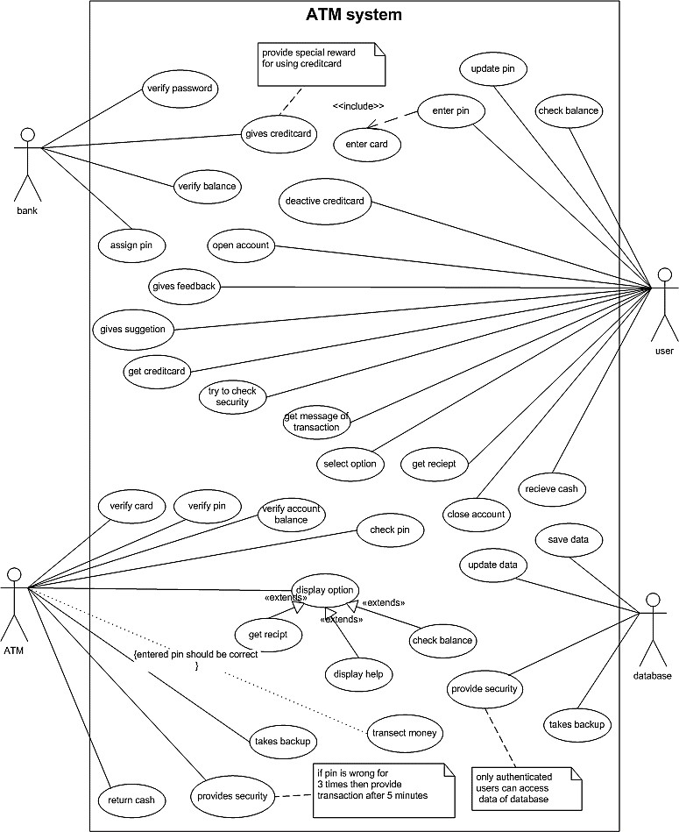

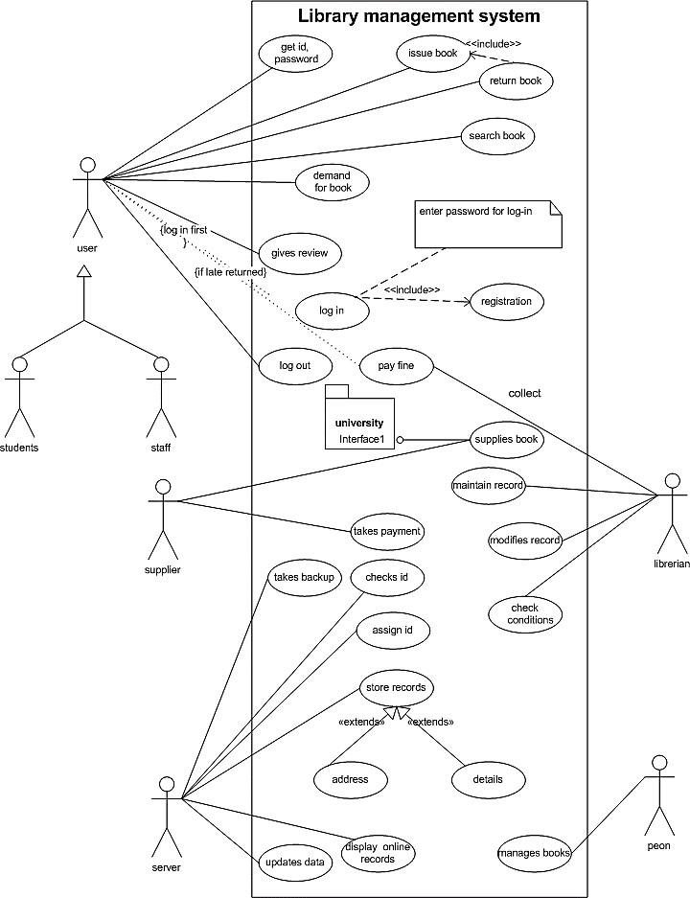

ER Diagram Symbols and Example

E-R Diagram Notations
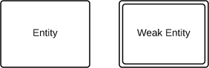
Entity •Entities are objects or concepts that represent important data. They are typically nouns, e.g. customer, supervisor, location, or promotion.
- Strong entities exist independently from other entity types. They always possess one or more attributes that uniquely distinguish each occurrence of the entity.
- Weak entities depend on some other entity type. They don't possess unique attributes (also known as a primary key) and have no meaning in the diagram without depending on another entity.
Relationship •Relationships are meaningful associations between or among entities. They are usually verbs ,e.g.as sign,
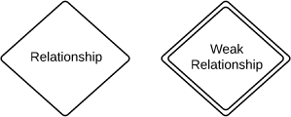
associate, or track.
- Weak relationships, or identifying relationships, are connections that exist between a weak entity type and its owner.

Attributes • Attributes are
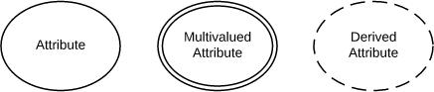
characteristics of either an entity, a many-to-many relationship, or a one-to-one relationship.

- Multivaluedattributesarethosethatarecapableoftakingonmorethanonevalue.
- Derivedattributesareattributeswhosevaluecanbecalculatedfromrelatedattributevalues.
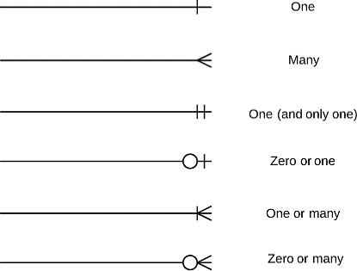
Association •Relationships illustrate an association between two tables. In the physical data model, relationships are represented by
stylized lines.
  - Cardinality and ordinality, respectively, refer to the maximum number of times an instance in one entity can be associated with instances in the related entity, and the minimum number of times an instance in one entity can be associated with an instance in the related entity. Cardinality and ordinality are represented by the styling of a line and its endpoint, as denoted by the chosen notation style

ER Diagram for University Examination

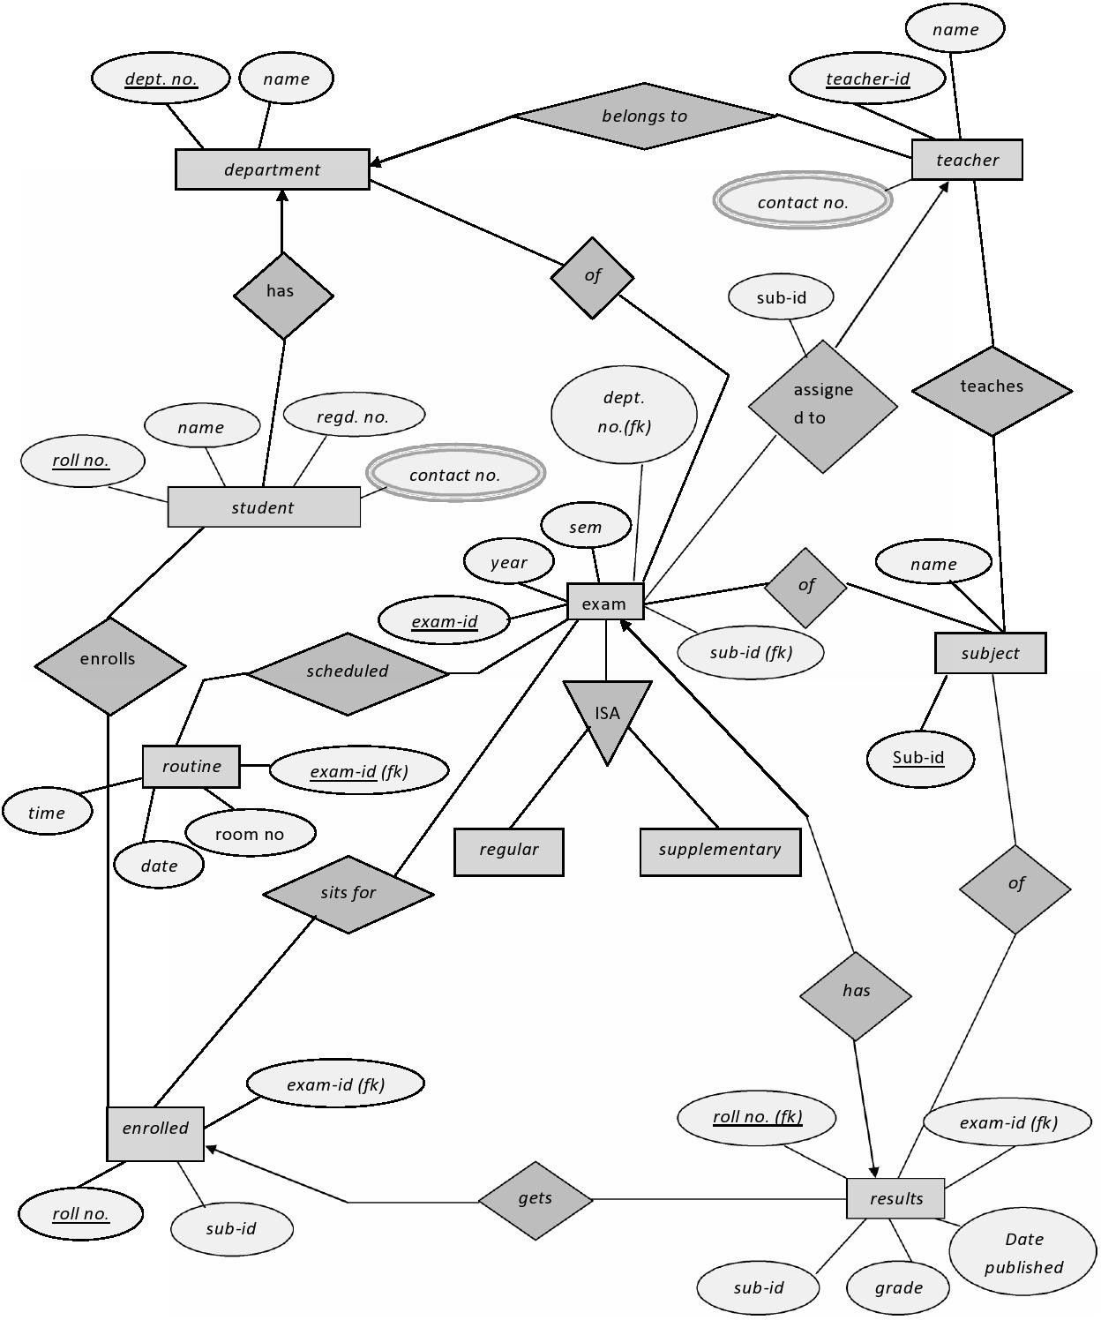

Context diagram and data flow diagram(DFD) for Airlines Reservation System.

Context diagram /Level0DFD
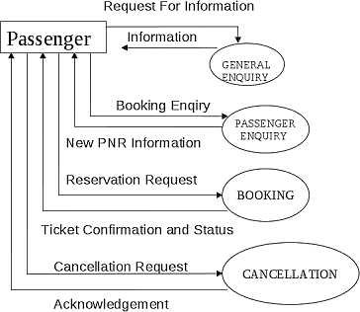

Level1DFD
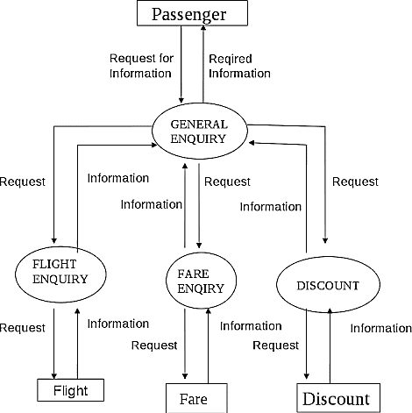

Level2DFD
